|  |  |  |  |  |  |
| --- | --- | --- | --- | --- | --- |
| Date | 12-Dec-22 | | | Tester Name | Janette Paus |
| Environment | Penfax - Test 2 | | | Login used | <If different from the Tester> |
| Operating System | Windows | Version: 21H2 | Update Number: | | |
| Software Used | Select Software | Version: 107.0.1418.56 | Update Number: | | |
| Select Software | Version: | Update Number: | | |
| Application Release version | R22.4.1 | | | | |
| Test Case Title | E13.11 | | | | |
| Test Type | Regression | | | | |
| Test Scenario | Add a contingent (alternate) PEPP Beneficiary - PENWEB | | | | |
| Expected Results | The beneficiary is added through PENWEB and reflected in PENFAX | | | | |
| Pass/Fail | Pass | | | JIRA# |  |

Search for a member to add a contingent beneficiary

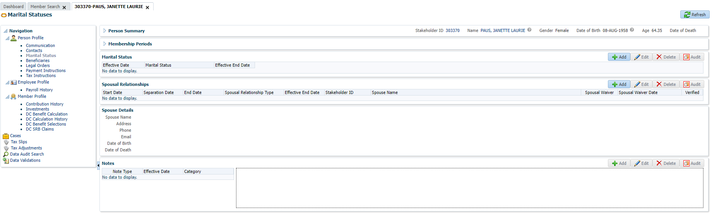

Open that member in Planet member PEPP

Under Beneficiary tab, add New Beneficiary

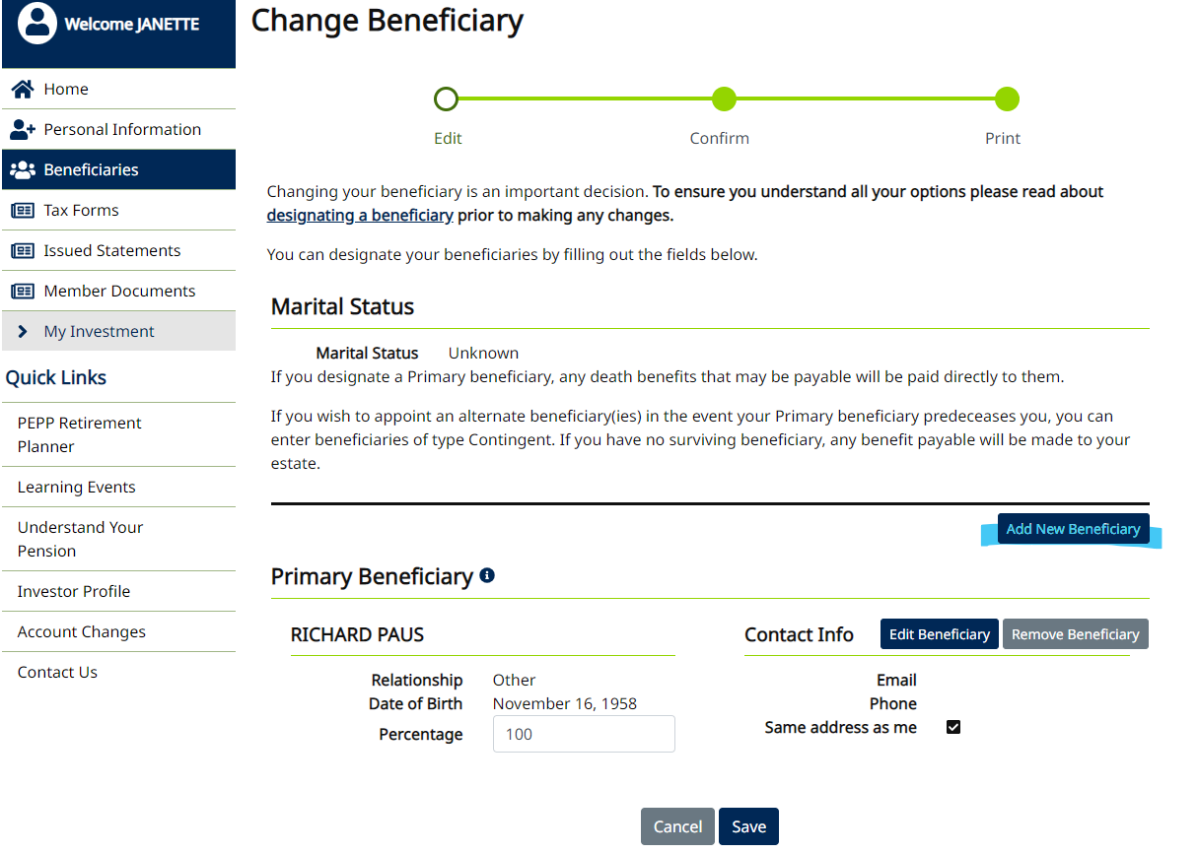

Select Person or Organization

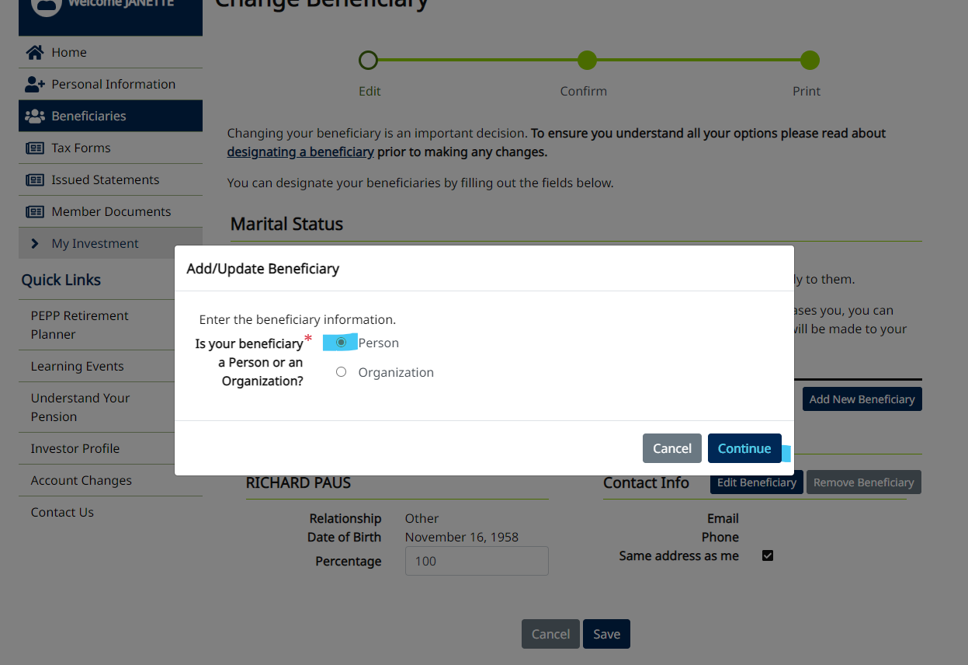

Enter details

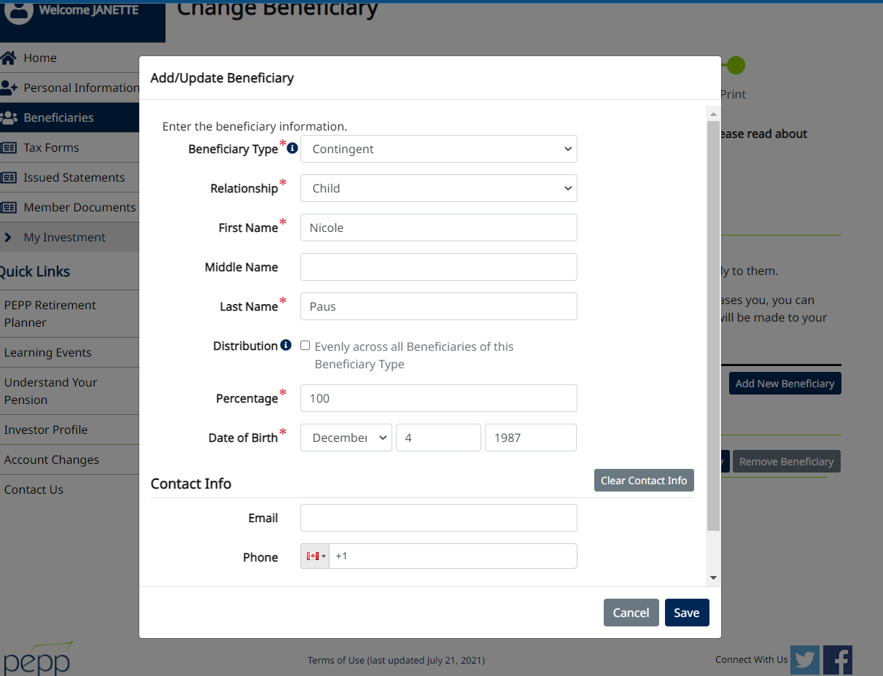

Save

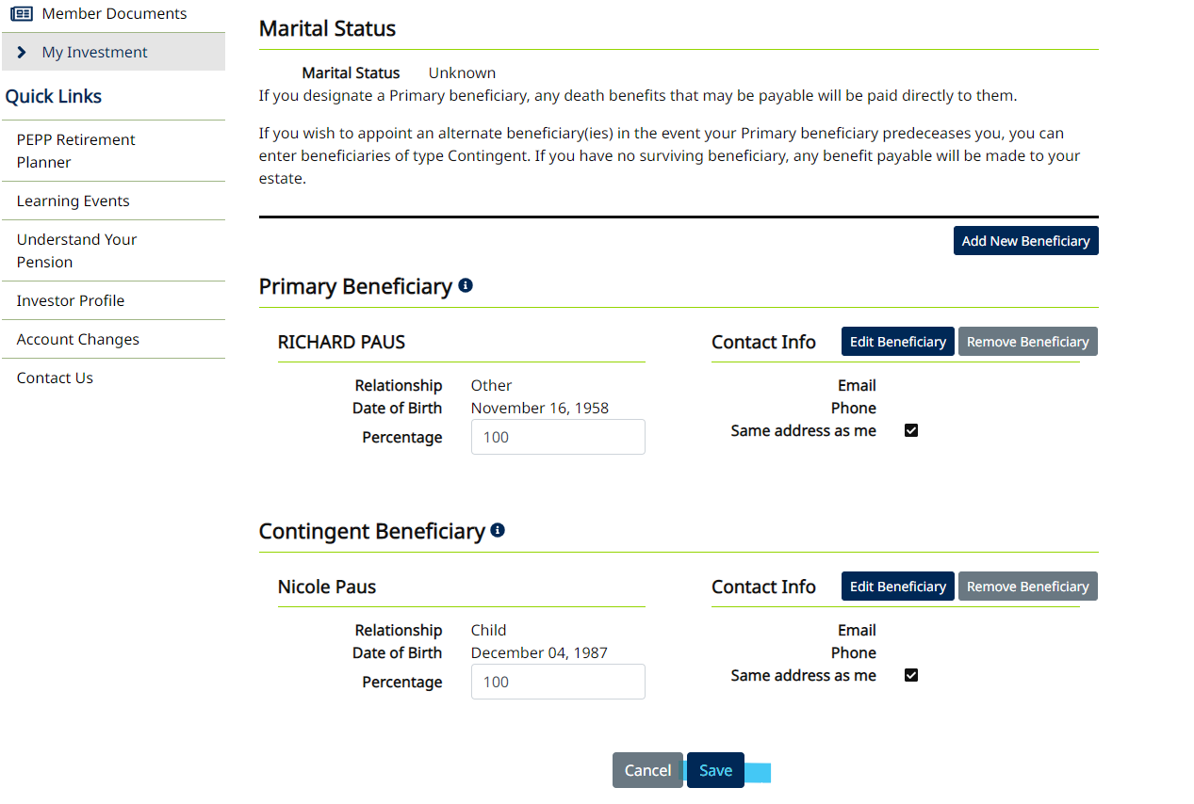

Confirm addition

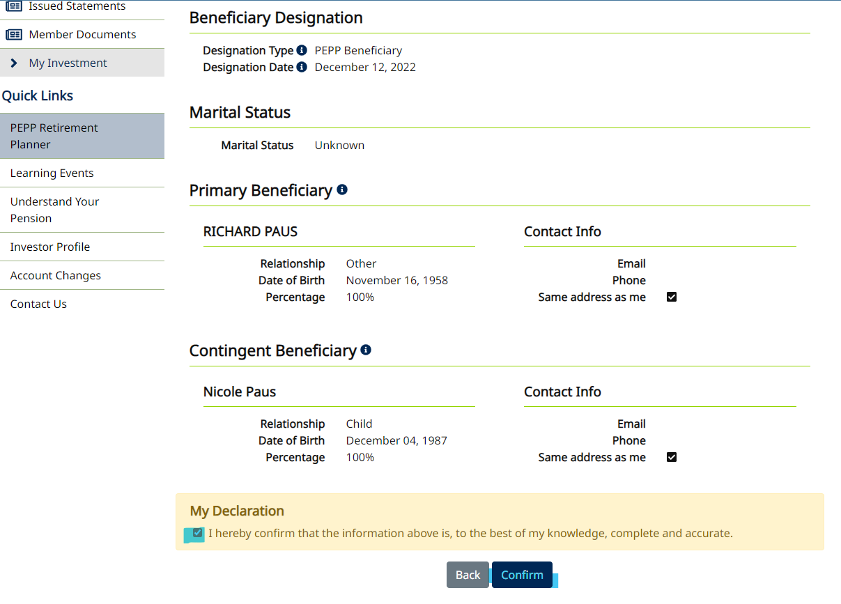

Print if needed

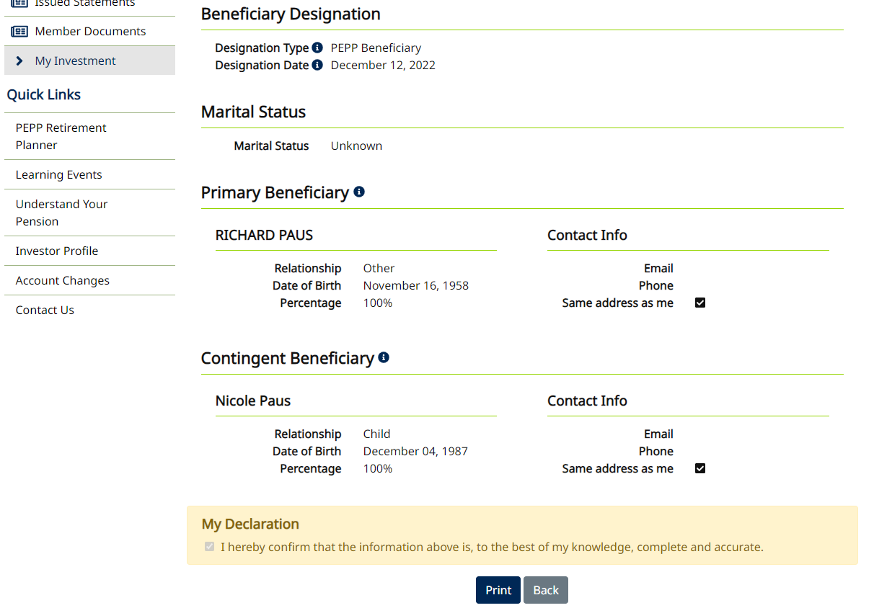

Refresh and beneficiary is added

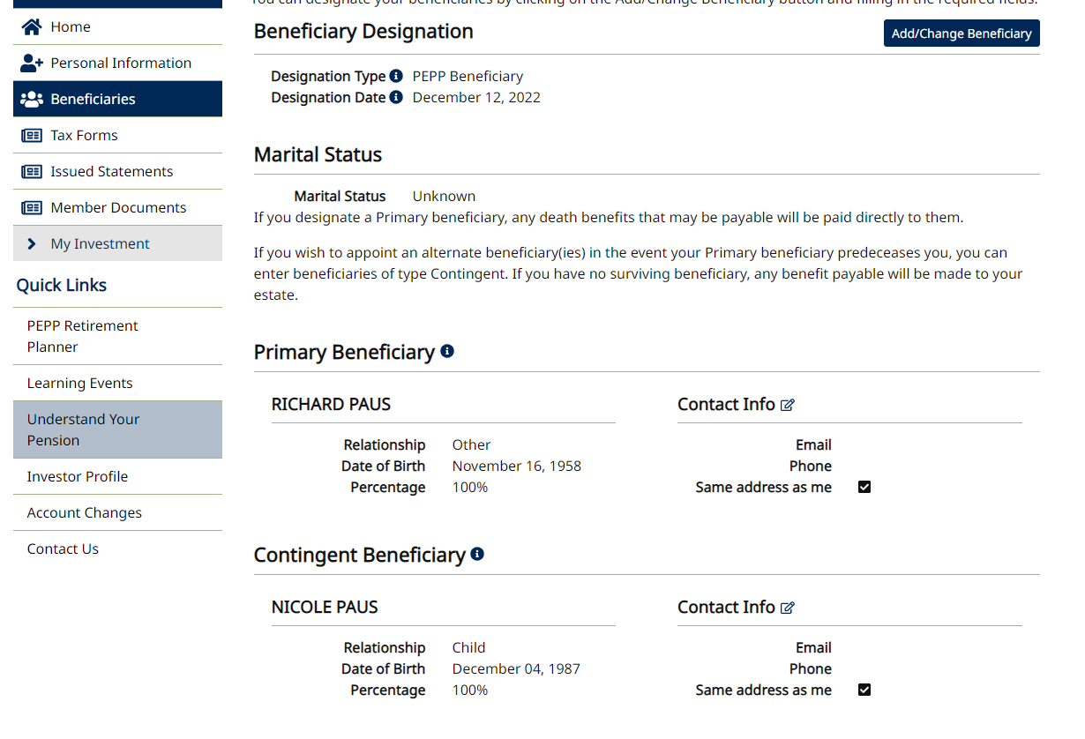

Confirm on PENFAX

